Sequence Diagrams – Regis

Sequence Diagram:

Adding to the Event Calendar

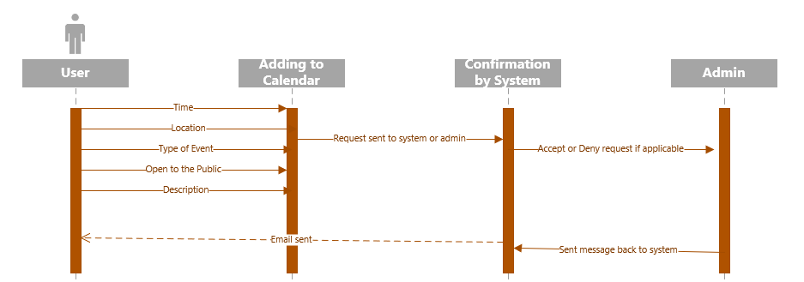

Modifying the Event Calendar

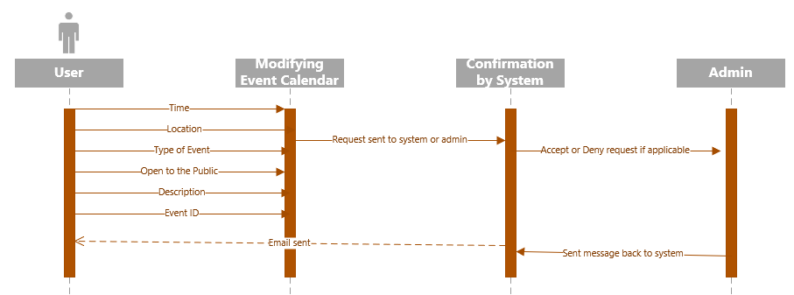

Deleting an event from the Event Calendar

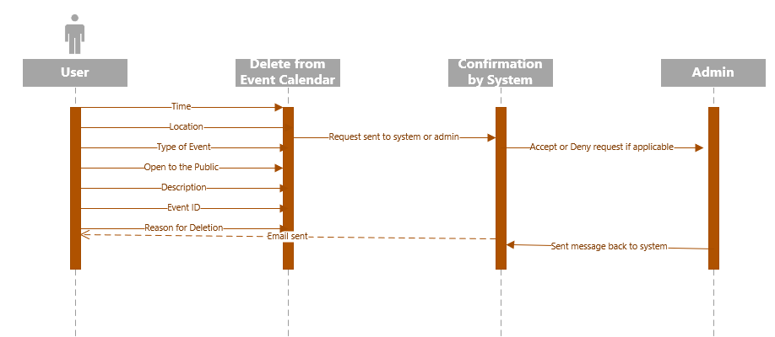

Billing and Shipping Information

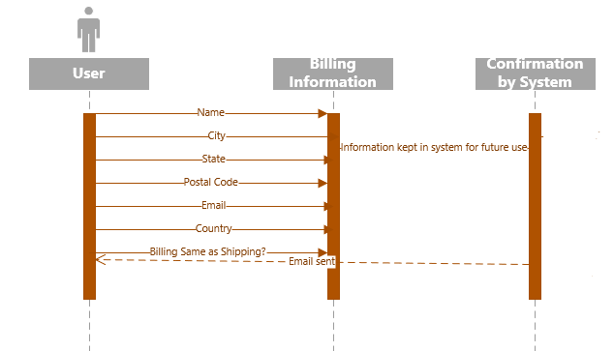

Making a Suggestion (Discussion Board)

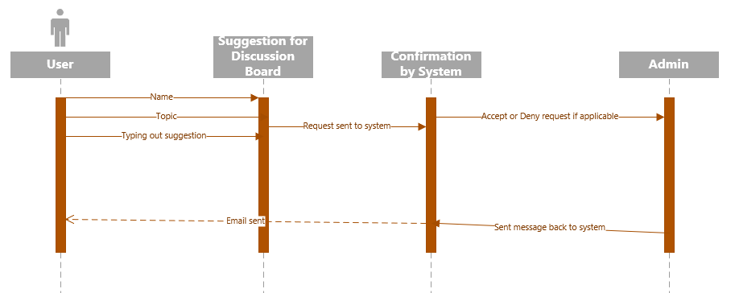

Ordering from Store

